Machine learning

Machine learning :

Machine learning means to train a algorithm test and predict the future based on past and current business performance . it is an part of AI means we are giving the power to a machine to automate some tasks

Types of machine learning :
- Supervised machine learning
- Unsupervised machine learning
- Supervised machine learning : the label and the attributes are defined to us
For ex : you are given that you need to number of pizzas that can be sold in domnios tomorrow based on todays data so in this case the output or the label you need is given to you that is y which means y is the sales you need to predict based on attributes
- Unsupervised machine learning : it means you don’t have label or tasks defined before
For ex : you have a data to predict the health of a paitent but there no attribute given so out of data you need to decide which attribute from data needs to be choosen for prediction
- RPA : robotic process automation it is an advanced types of ML which means that you are basically automating whole system
** the key difference between the supervised and unsupervised is that supervised is used when we need to predict based on past data but unsupervised can also include some cases where you don’t have the data you need to have a prediction

Algorithms in machine learning :
Supervised machine learning :
In supervised ML an algorithm learn from labeled data means the training data that includes both input and output . the thing is to predict the output for unseen data
- Linear regression :
It means to predict the continuous values like price , temperature or salary
It only works on numerical data
Example : house price prediction , sales prediction
Formula = y=mx+b

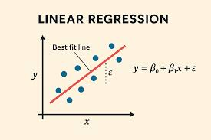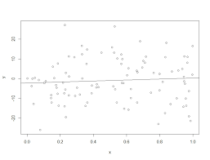
Y=mx+c
Slope
Y is the prediction you are making
M is the slope
C is constant and
……. These are data points
Second model is worst fit
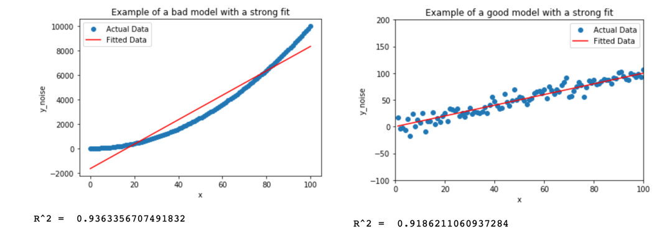

- Logistic regression
Logistic regression is a classification algorithm
Classification means categorical data
For ex: mail is spam or not
Ex: spam mail detection
- Decision trees:
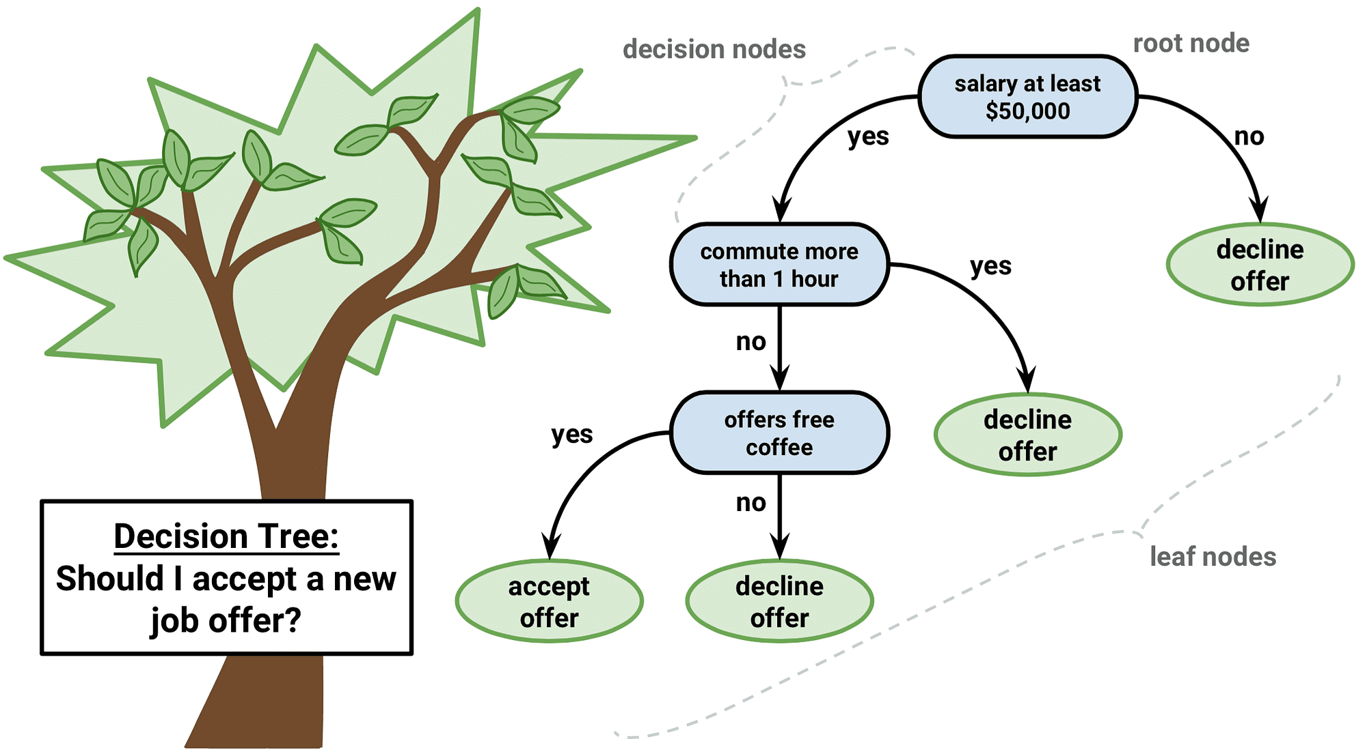
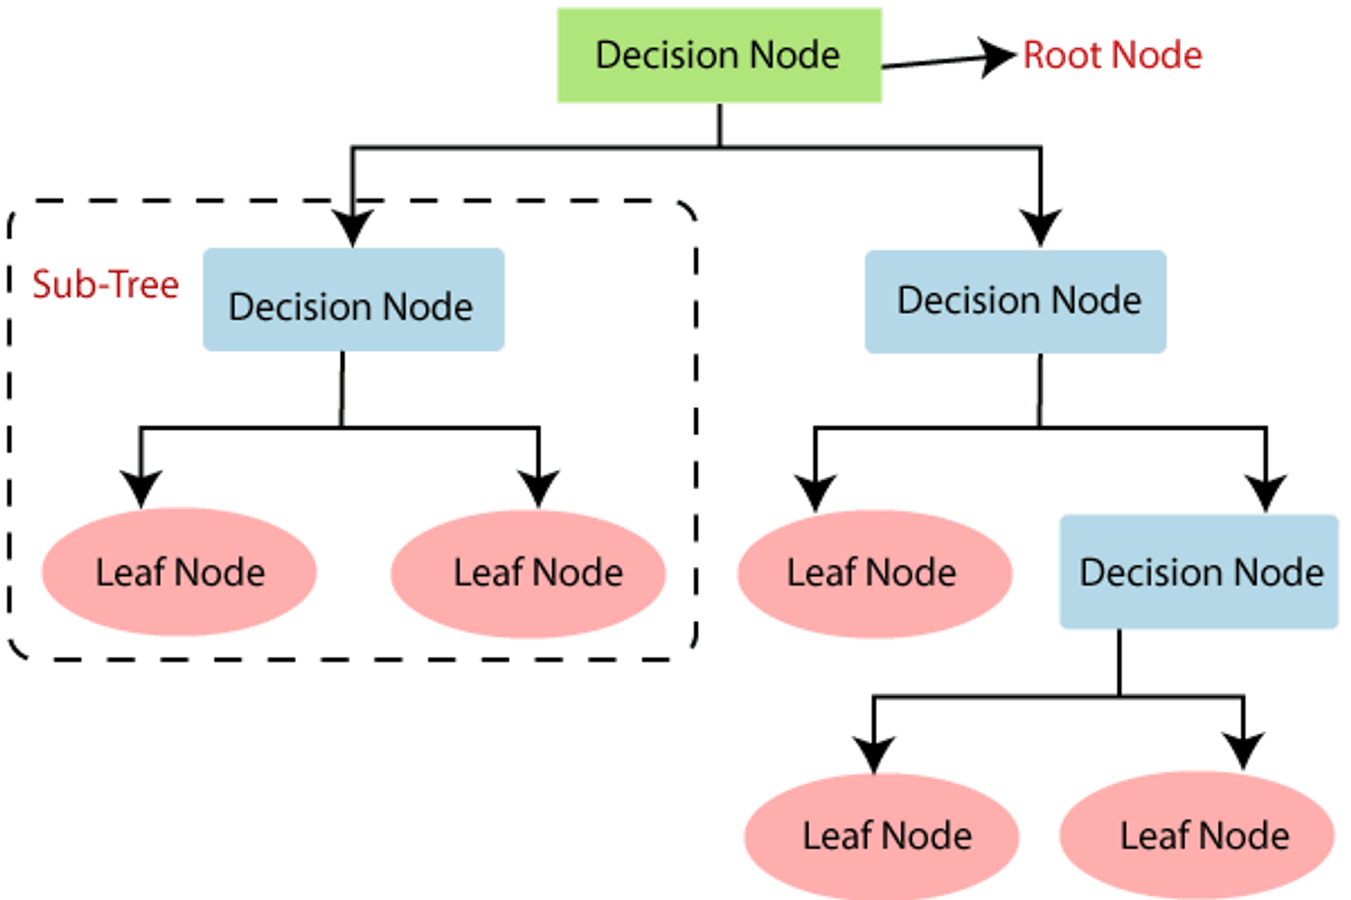
It is used when you need to make a decision for ex : loan approval systems
ATS tracking system

- Random forest :
A collection of many descision tress conbined together
Ex: fraud detection
Medical diagnosis
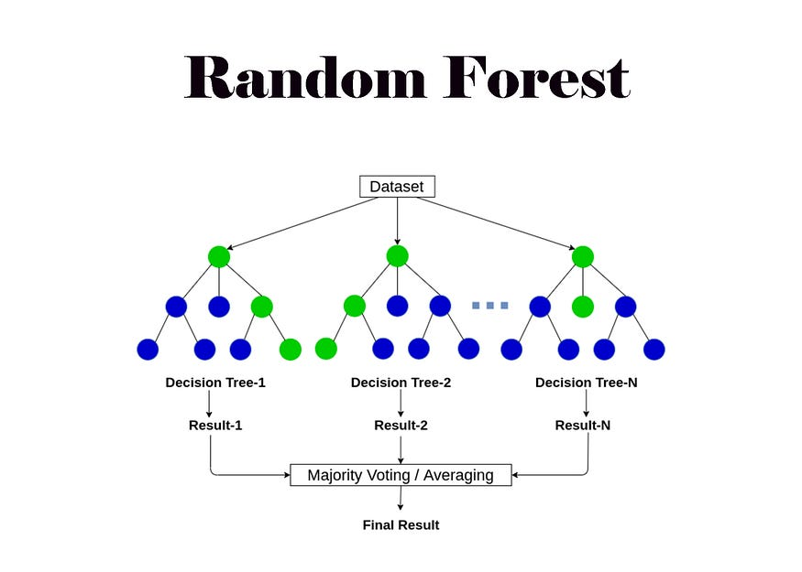
- Support vector machine : svm
Finds the best boundary separating classes
Ex: face recognition
Text classification
- K – nearest neighbor :
It works on grouping or clustering
For ex: recommendation systems
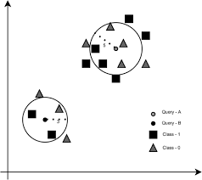

Algorithm uses :
- Linear Regression : numerical prediction of data
- Logistic Regression : it is used for classification
- Decision Tress: it is used for both classification and regression
- Random Forest : when you want to fins the highest accuracy it used on both numerical and classification
- SVM : complex classification
- KNN : used for similarity only
How you see if your model is best fit ?
Bias – variance trade-off

Overfitting
Underfitting
Besfit

if your model is working good on training data but its not working well on testing its overfitting
if your model is not working well on training but good on testing its underfitting
if your model works best on training and best on testing its bestfit

we need bestfit model
